Supplementary Information
Postoperative morbidity and mortality of a defunctioning stoma formed at radical sphincter-preserving surgery for rectal cancer: a systematic review and meta-analysis of proportions

Contents
Table S1. PRISMA 2020 checklist with manuscript locations.
Table S2. Full Boolean search strategies with record counts and execution dates.
Table S3. Characteristics of the 74 included studies.
Table S4. Studies excluded at full-text assessment, with reasons.
Table S5. Newcastle-Ottawa item and total scores for each non-randomised study, and RoB 2 domain judgements for each randomised trial.
Figure S1. Anastomotic leakage stratified by stoma type.
Figure S2. Anastomotic leakage stratified by study design.
Figure S3. Anastomotic leakage stratified by publication era.
Figures S4-S6. Sensitivity analysis using the broadest leak definition reported by each study.
Figure S7. Funnel plot for the sensitivity analysis of anastomotic leakage.
Tables S1-S5 вставить, подумать над S3 и S5 – училит статью, если нет - вырезать

Figure S1. Pooled prevalence of clinically relevant anastomotic leakage stratified by stoma type. Cohorts confined to loop ileostomy are compared with cohorts containing both loop ileostomies and loop colostomies. Squares are study-specific proportions, horizontal lines are 95% confidence intervals, diamonds are subgroup and overall pooled estimates from a random-effects generalised linear mixed model with a logit link.
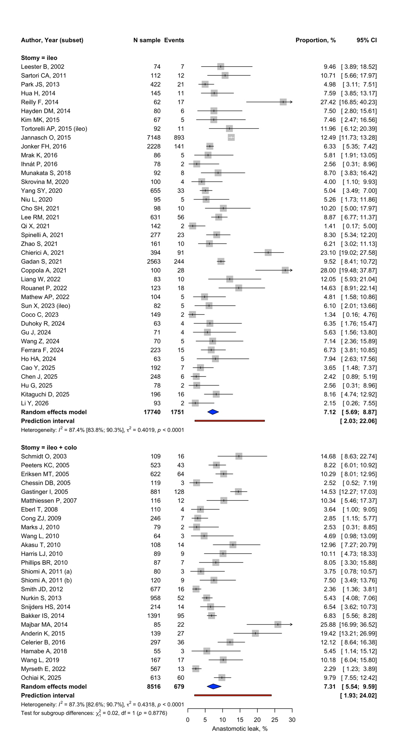

Figure S2. Pooled prevalence of clinically relevant anastomotic leakage stratified by study design (retrospective cohort, prospective cohort, randomised controlled trial). Constructed as in Fig. S1.
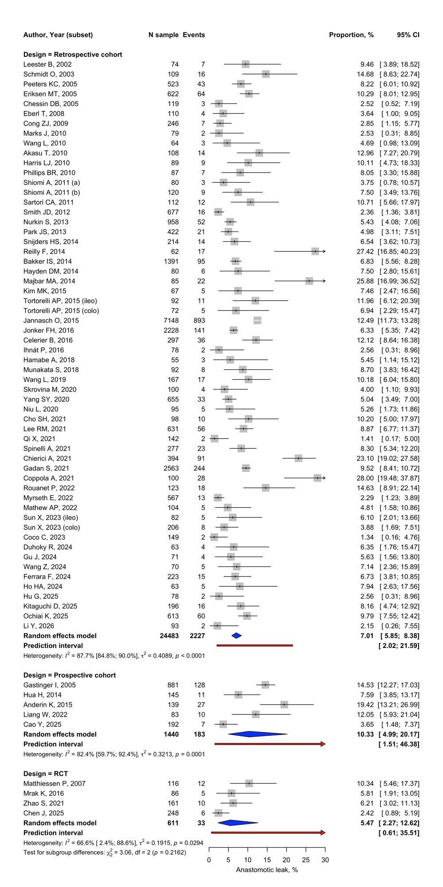

Figure S3. Pooled prevalence of clinically relevant anastomotic leakage stratified by publication era (before 2010, 2010-2019, 2020 onwards). Constructed as in Fig. S1.
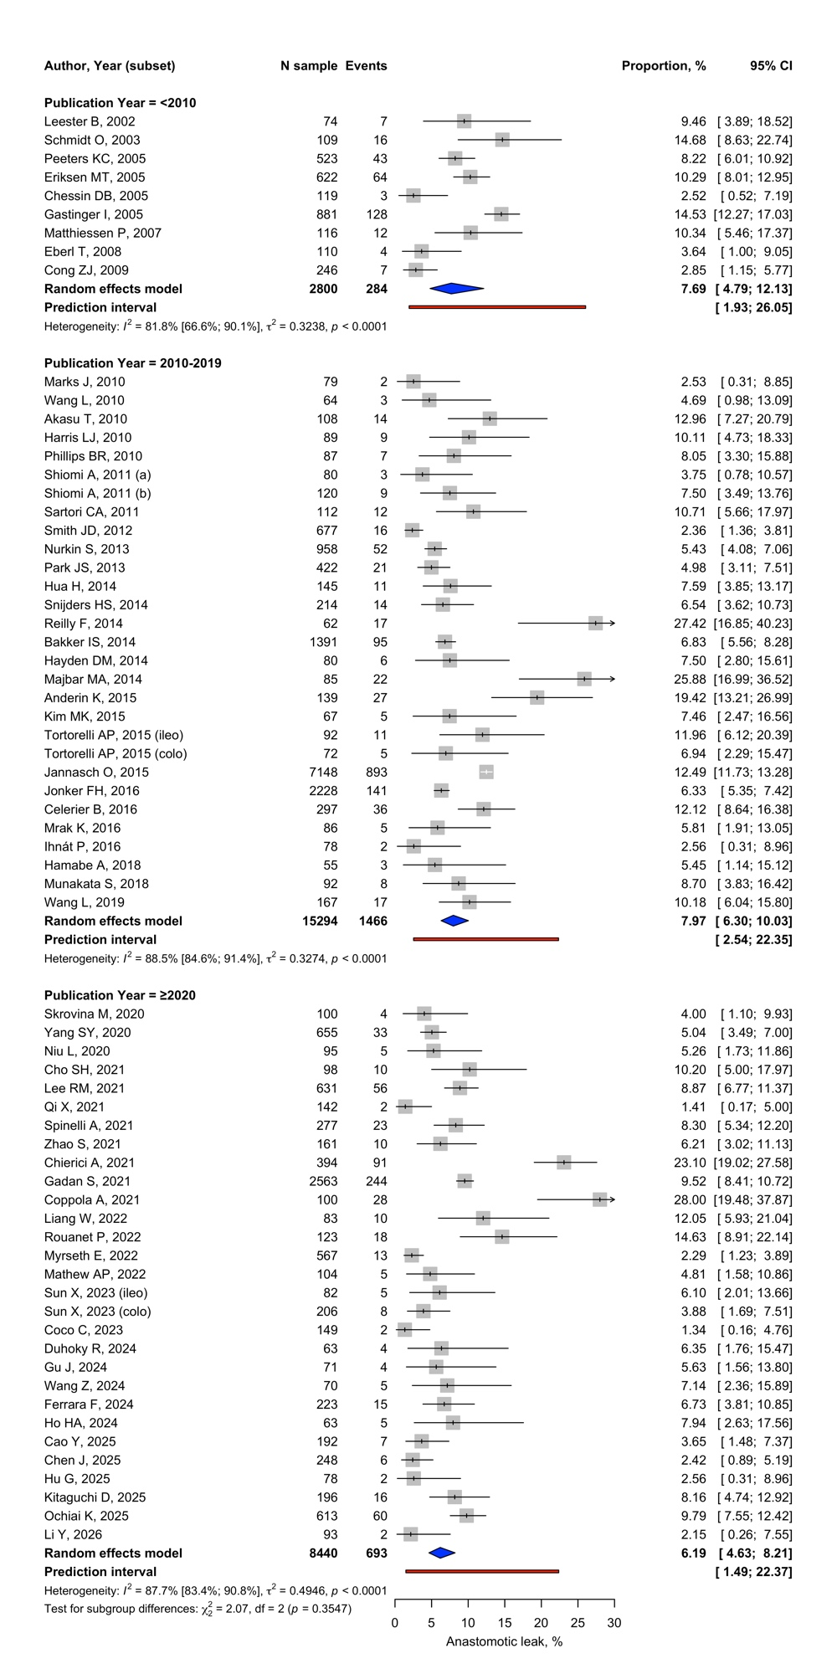

Figure S4. Sensitivity analysis of anastomotic leakage using the broadest leak definition reported by each study, all contributing estimates. Constructed as in Fig. S1.
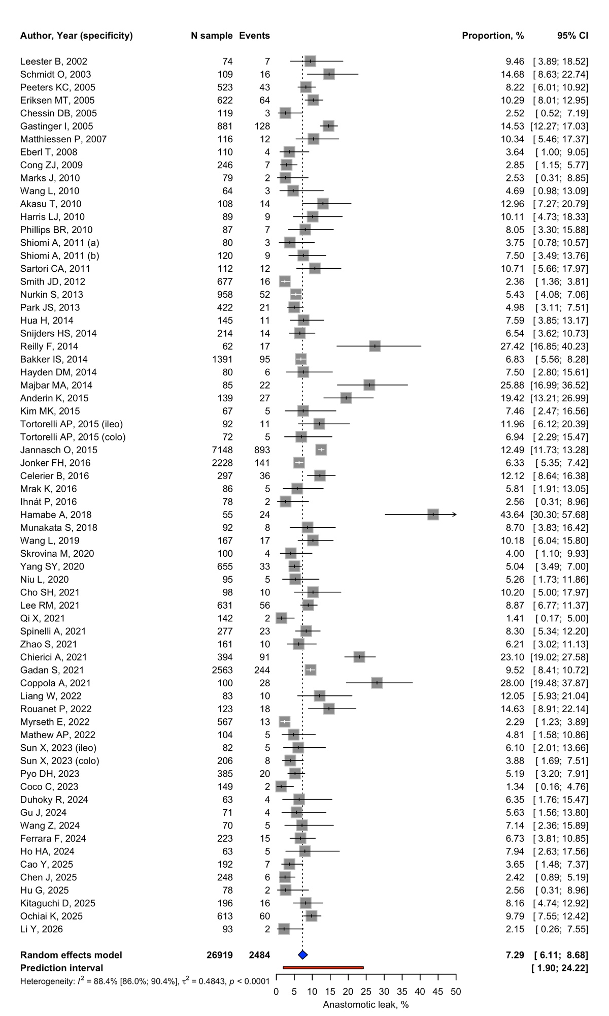

Figure S5. Sensitivity analysis using the broadest leak definition, stratified by study design. Constructed as in Fig. S1.
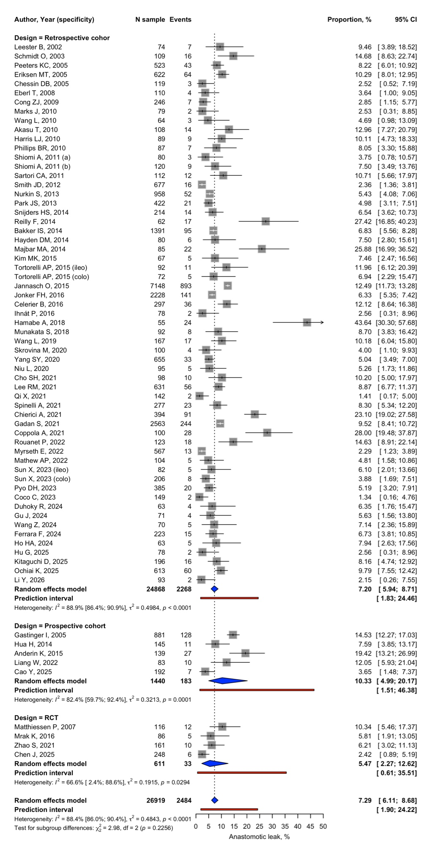

Figure S6. Sensitivity analysis using the broadest leak definition, stratified by stoma type. Constructed as in Fig. S1.
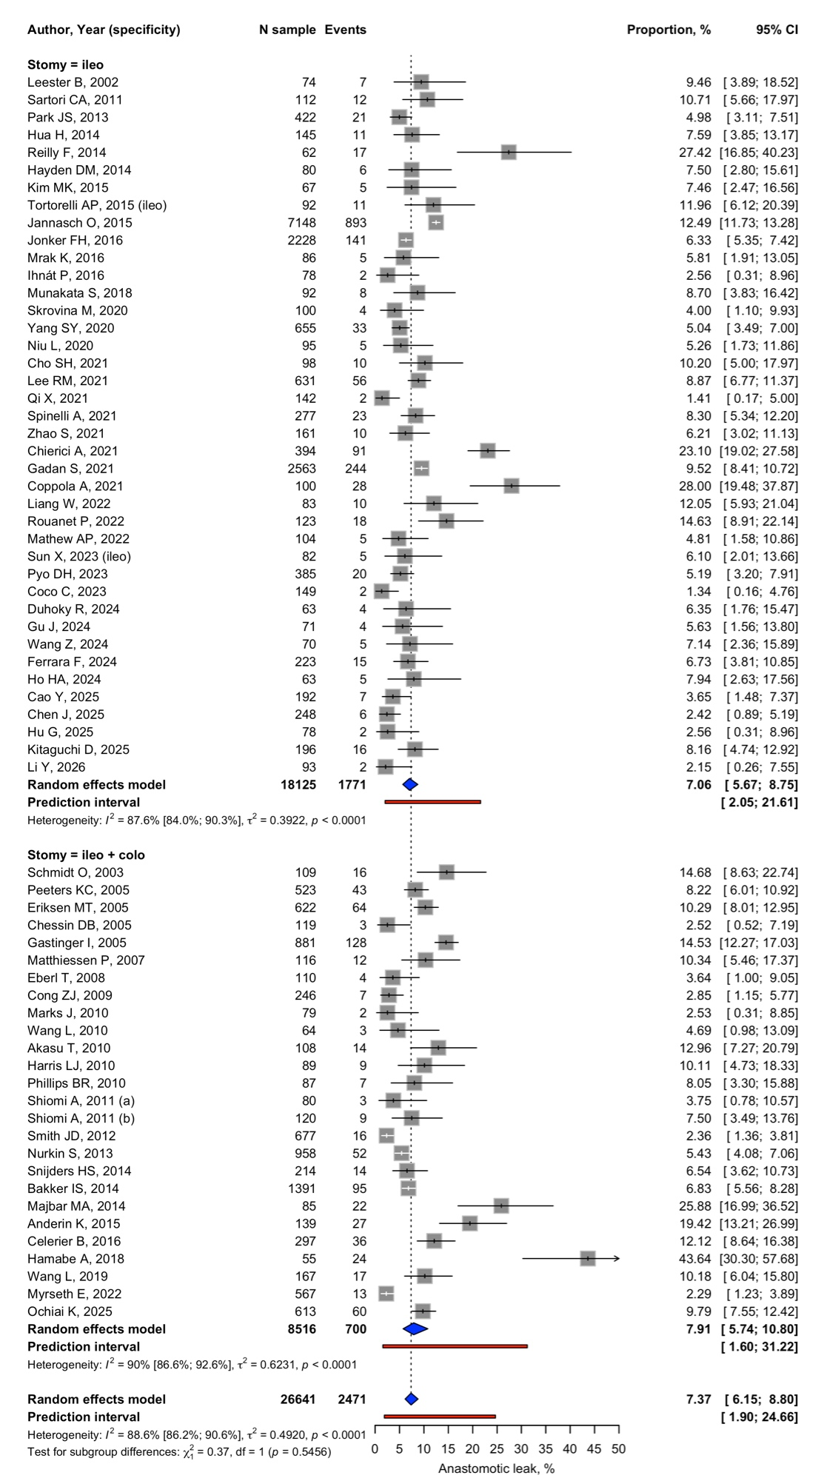

Figure S7. Funnel plot of logit-transformed proportions against standard error for the sensitivity analysis of anastomotic leakage using the broadest leak definition. Dashed lines indicate the pooled estimate and its pseudo 95% confidence region.


